Rooted & Growing: Tu Bishvat

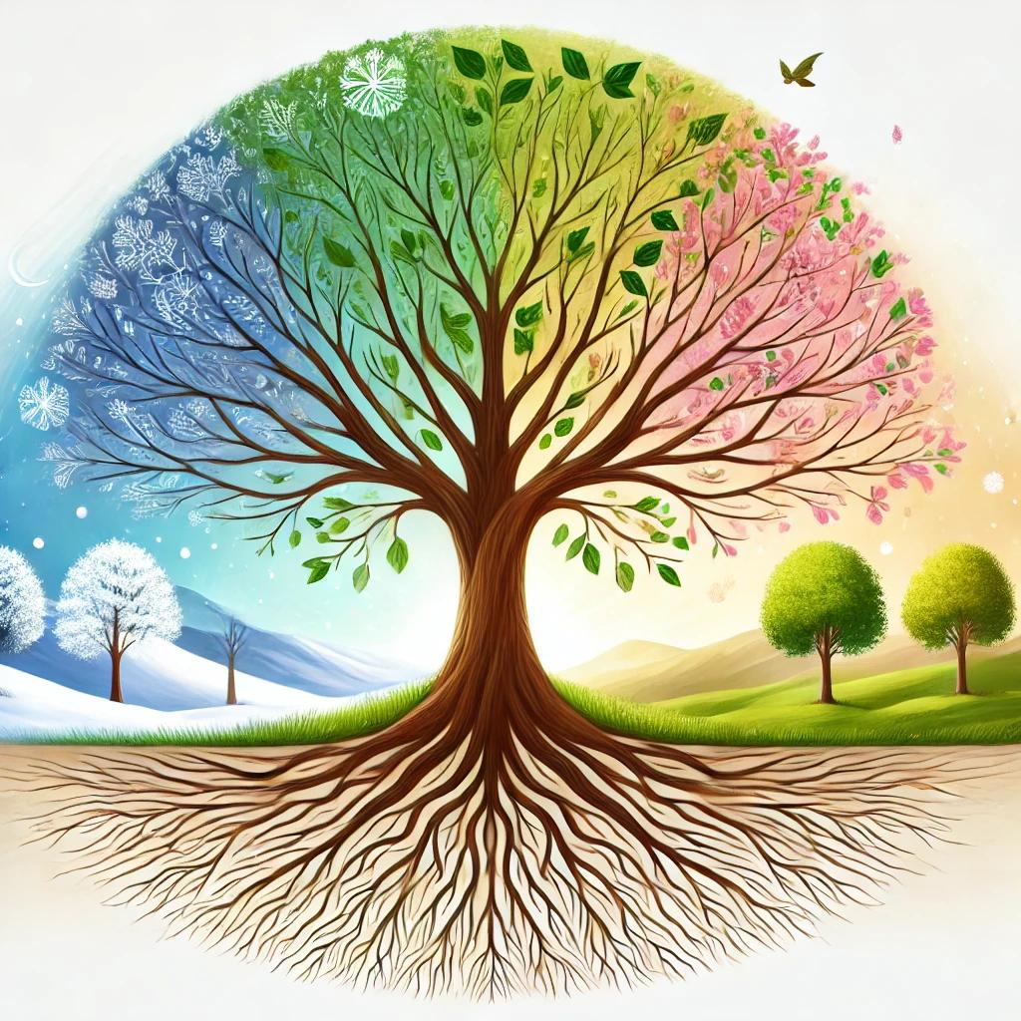
#1
Real growth takes time and persistence, by Rabbi Menachem Lehrfield, Aish.com
Why does Judaism celebrate Tu Bishvat, the New Year for trees, right in the middle of winter when trees stand bare against a gray sky, seemingly lifeless?
The answer reveals an essential lesson about personal growth and unlocking human potential.
The timing of Tu Bishvat emerges from deep roots in Jewish law. The Talmud in Rosh Hashana establishes the 15th of the month of Shvat (in Hebrew ‘Tu” means 15 and Shvat is the name of the month) as one of the four new years in the Jewish calendar.
It has legal significance in terms of setting the agricultural year for tithes as well as a festive component making it a minor holiday.
This elevation of what might seem a minor agricultural milestone speaks to something far deeper than mere seasonal marking…

#2
Torah, Devarim 20:19
For man is like the tree of the field.

Questions:
- How do you relate to the idea that a person is like a tree? What qualities of a tree (roots, growth, branches, fruit) resonate most with your personal journey?
- What are the “roots” that keep you grounded in your life? What are the “fruits” you want to produce in your life?
- If someone’s “roots” (background, upbringing) are weak, do you think they can still grow strong? What personal choices determine a person’s future more: their roots or their branches?
#3
Kohelet (Ecclesiastes) 3:1
To everything there is a season, and a time for every purpose under the heavens.

Questions:
- Society often pushes us to follow a timeline- college, career, marriage, success. Have you ever felt pressured to achieve something by a certain time?
- How do you resist comparing your “season” to someone else’s?
- Some fruits ripen quickly, others take years to mature. In what areas of your life do you expect fast results, and where do you allow for slow, steady growth?
- How do you know when to push for growth and when to let things develop naturally? Is waiting always wise, or can it sometimes be an excuse for inaction?

